FINAL REPORT

Heritage Treasures: An In-Depth Analysis of UNESCO World

Heritage Sites in Tableau

# INTRODUCTION

1.1 Project Overview

UNESCO World Heritage Sites are places recognized for their cultural or natural importance. These sites tell the story of human history and natural wonders. Our project focuses on exploring data related to these sites using Tableau, a powerful data visualization tool. The goal is to help people understand patterns, insights, and trends in heritage preservation across the world.

1.2 Purpose

The purpose of this project is to analyze and visualize heritage site data in an interactive and meaningful way. By using Tableau, we aim to bring awareness about world heritage, show which countries have the most sites, highlight endangered sites, and help in understanding how cultural and natural heritage is spread across the globe.

# IDEATION PHASE

2.1 Problem Statement

To build a data visualization dashboard that helps analyze UNESCO World Heritage Sites by country, continent, type, status, and year of inscription using Tableau.

2.2 Empathy Map Canvas

We focused on what heritage enthusiasts, educators, and travelers:

* Think & Feel: Curious about history, want to explore diverse cultures
* See: Data in boring tables, hard to understand insights
* Hear: News about endangered sites or new additions
* Say & Do: Look for maps, stats, and visual stories online
* Pain: Difficult to access meaningful information easily
* Gain: A clear, engaging, visual experience that educates and inspires

2.3 Brainstorming

We listed ideas like:

* Creating maps of heritage site locations
* Showing trends over time
* Highlighting endangered sites
* Comparing cultural vs natural sites
* Using filters to allow users to explore their interests

# REQUIREMENT ANALYSIS

3.1 Customer Journey Map

|  |  |  |  |  |
| --- | --- | --- | --- | --- |
| Stage | Action | Tool | Emotion | Opportunity |
| Discover | User finds our dashboard | Tableau Public | Curious | Impress with visuals |
| Explore | Filters by country/type | Filters | Engaged | Add story sections |
| Learn | Sees endangered sites | Graphs | Surprised | Promote awareness |
| Share | Shares dashboard | Link | Proud | More reach & impact |

3.2 Solution Requirement

* Dataset of UNESCO heritage sites
* Tableau for dashboard creation
* Charts: maps, bar charts, line graphs, pie charts
* Filters: country, type, year, status 3.3 Data Flow Diagram

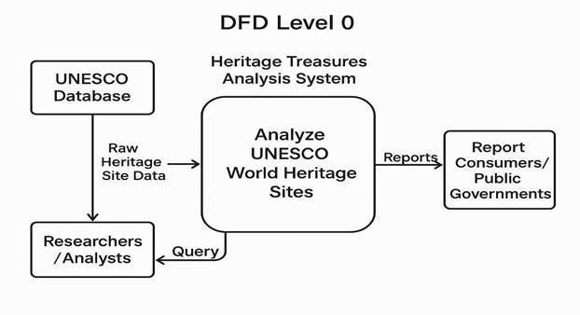

3.4 Technology Stack

* Frontend: Tableau Public,python
* Backend: flask(data-based project)
* Preprocessing Tool: Excel / Google Sheets
* Data Source: https://[www.kaggle.com/datasets/ujwalkandi/unesco-world-](http://www.kaggle.com/datasets/ujwalkandi/unesco-world-) heritagesites/data?select=whc-sites-2019.csv

# PROJECT DESIGN

4.1 Problem-Solution Fit

The problem was that raw heritage site data was hard to interpret. The solution was to make it interactive and visual, helping users understand it easily.

4.2 Proposed Solution

An interactive Tableau dashboard that shows insights such as:

* Number of heritage sites per country
* Growth over time
* Endangered sites
* Cultural vs Natural site comparisons

4.3 Solution Architecture

* Data collected from UNESCO
* Preprocessing to clean and prepare
* Imported into Tableau
* Dashboards created using maps, filters, and charts
* Published on Tableau Public for public access

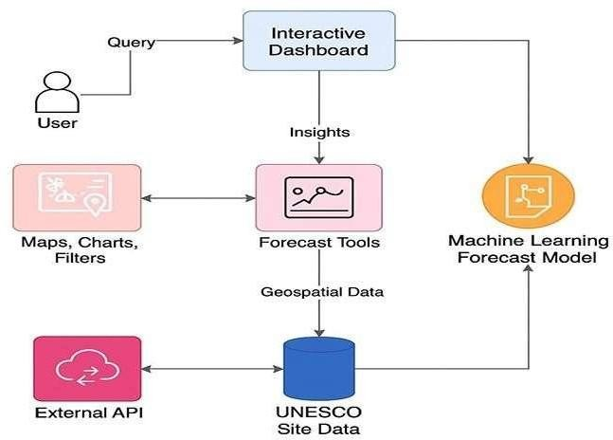

# PROJECT PLANNING & SCHEDULING

5.1 Project Planning

Week Task

1. Data Collection and Understanding

1. Data Cleaning and Preprocessing

1. Creating Dashboards in Tableau

1. Designing Story Slides

1. Final Testing and Review

1. Documentation and Report Writing

1. FUNCTIONAL AND PERFORMANCE TESTING
   1. Performance Testing

We tested the dashboard on different devices and browsers. It loaded quickly and worked well. Filters and visuals responded smoothly, and no lag was noticed.

1. RESULTS
   1. Output Screenshots

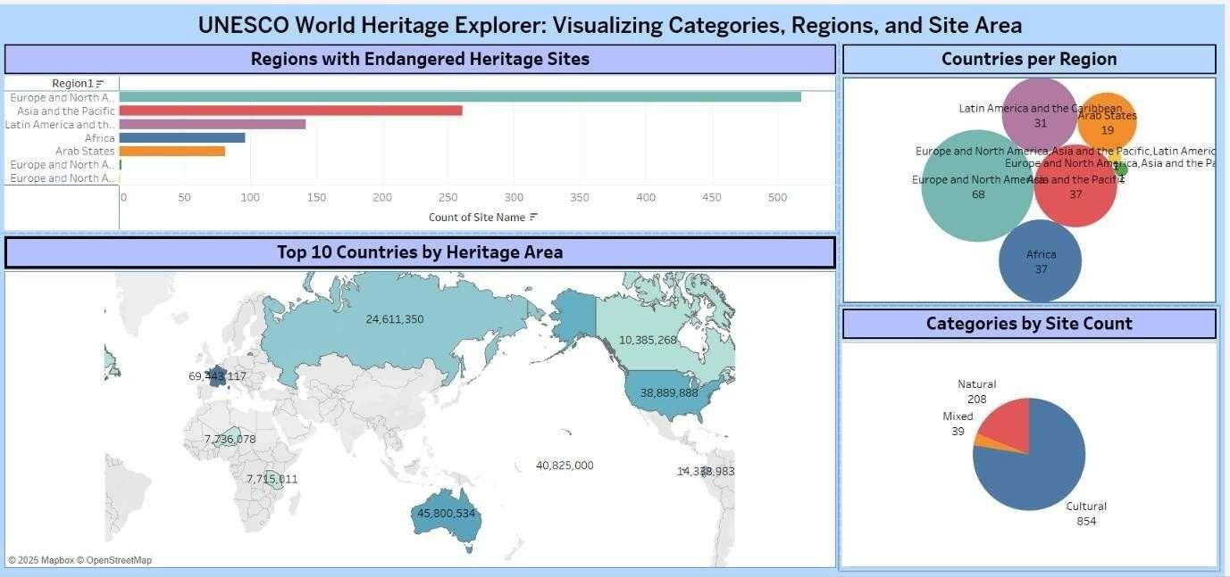

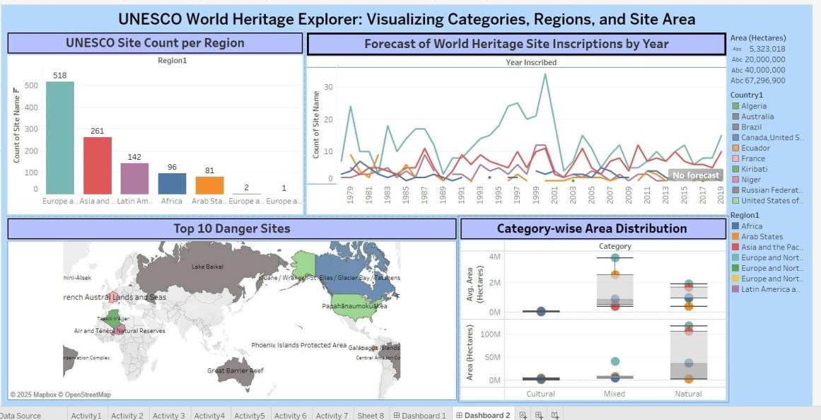

1. ADVANTAGES & DISADVANTAGES

Advantages

* + - Easy to understand visual data
    - Interactive filters for personalized views
    - Helps raise awareness about endangered sites
    - Can be accessed publicly and shared

Disadvantages

* + - Static dataset (not live updating)
    - No prediction or AI involved
    - Depends on the accuracy of source data

1. CONCLUSION

The project successfully transformed a raw heritage dataset into a rich, interactive visual experience using Tableau. Users can now explore, learn, and appreciate world heritage more easily. This project shows how data science can help in promoting culture and history.

1. FUTURE SCOPE
   * + Add real-time data updates using APIs
     + Include images or videos of sites
     + Build a mobile-friendly version
     + Enable AI-based recommendations or predictions

1. Source Code:

<!DOCTYPE html>

<html lang="en">

<head>

<meta charset="UTF-8">

<meta name="viewport" content="width=device-width, initial-scale=1.0">

<title>Heritage Treasures</title>

<link href="[https://cdn.jsdelivr.net/npm/bootstrap@5.3.0/dist/css/bootstrap.min.css"](https://cdn.jsdelivr.net/npm/bootstrap%405.3.0/dist/css/bootstrap.min.css) rel="stylesheet"> <style> body { font-family: 'Segoe UI', sans-serif;

}

.hero {

background-image:

url('https://upload.wikimedia.org/wikipedia/commons/thumb/2/23/UNESCO_World_Heritage_

Map_2020.svg/1920px-UNESCO_World_Heritage_Map_2020.svg.png'); background-size: cover; background- position: center; height: 100vh; color: black; text-shadow: 2px 2px 4px rgba(0, 0,

0, 0.7);

}

.hero-content { text- align: center; padding- top: 20%;

}

.section-title { margin- top: 60px;

}

</style>

</head>

<body>

<header class="hero">

<div class="hero-content">

<h1 class="display-4 fw-bold">Heritage Treasures</h1>

<p class="lead">An In-Depth Analysis of UNESCO World Heritage Sites</p>

</div>

</header>

<section class="container" id="about">

<h2 class="section-title">About the Project</h2>

<p>This project explores UNESCO World Heritage Sites through the lens of data. Using Tableau, we bring the data to life with interactive visuals that uncover patterns, highlight endangered sites, and help understand the global heritage landscape more deeply. Our goal is to raise awareness and offer an engaging learning experience about our world's cultural and natural treasures.</p>

</section>

<section class="container" id="features">

<h2 class="section-title">Key Features</h2>

<ul>

<li>Interactive visualizations using Tableau</li>

<li>Country-wise and continent-wise breakdown</li>

<li>Insights into endangered sites</li>

<li>Category-wise comparison: Cultural, Natural, and Mixed</li>

</ul>

</section>

<section class="container" id="dashboards">

<h2 class="section-title">Visual Insights</h2>

<div class="mb-5">

<h4>Dashboard 1: Global Heritage Overview</h4>

<div class='tableauPlaceholder' id='viz1750820362536' style='position: relative'>

<noscript><a href='#'><img alt='UNESCO World Heritage Explorer: Visualizing Categories, Regions, and Site Area ' src='https://public.tableau.com/static/images/pr/pro_17507582009030/Dashboard1/1_rss.png' style='border: none' /></a></noscript>

<object class='tableauViz' style='display:none;'>

<param name='host_url' value='https%3A%2F%2Fpublic.tableau.com%2F' />

<param name='embed_code_version' value='3' />

<param name='site_root' value='' />

<param name='name' value='pro_17507582009030/Dashboard1' />

<param name='tabs' value='no' />

<param name='toolbar' value='yes' />

<param name='static_image' value='https://public.tableau.com/static/images/pr/pro_17507582009030/Dashboard1/1.png' />

<param name='animate_transition' value='yes' />

<param name='display_static_image' value='yes' />

<param name='display_spinner' value='yes' />

<param name='display_overlay' value='yes' />

<param name='display_count' value='yes' />

<param name='language' value='en-US' />

<param name='filter' value='publish=yes' />

</object>

</div>

<script type='text/javascript'> var divElement = document.getElementById('viz1750820362536'); var vizElement = divElement.getElementsByTagName('object')[0]; if

(divElement.offsetWidth > 800) { vizElement.style.width =

'100%'; vizElement.style.height = '700px'; } else if

(divElement.offsetWidth > 500) { vizElement.style.width =

'100%'; vizElement.style.height = '700px';

} else {

vizElement.style.width = '100%'; vizElement.style.height = '1277px';

}

var scriptElement = document.createElement('script');

scriptElement.src = 'https://public.tableau.com/javascripts/api/viz_v1.js'; vizElement.parentNode.insertBefore(scriptElement, vizElement);

</script>

<p>This dashboard presents a global map of UNESCO World Heritage Sites categorized by their type—Cultural, Natural, or Mixed. It allows users to see how heritage is distributed across continents and explore each country's contributions to global heritage. Filters enable focused analysis by year, region, or site type.</p>

</div>

<div class="mb-5">

<h4>Dashboard 2: Insights by Type & Country</h4>

<div class='tableauPlaceholder' id='viz1750820329593' style='position: relative'>

<noscript><a href='#'><img alt='UNESCO World Heritage Explorer: Visualizing Categories, Regions, and Site Area ' src='https://public.tableau.com/static/images/pr/pro_17507582009030/Dashboard2/1_rss.png' style='border: none' /></a></noscript>

<object class='tableauViz' style='display:none;'>

<param name='host_url' value='https%3A%2F%2Fpublic.tableau.com%2F' />

<param name='embed_code_version' value='3' />

<param name='site_root' value='' />

<param name='name' value='pro_17507582009030/Dashboard2' />

<param name='tabs' value='no' />

<param name='toolbar' value='yes' />

<param name='static_image' value='https://public.tableau.com/static/images/pr/pro_17507582009030/Dashboard2/1.png' />

<param name='animate_transition' value='yes' />

<param name='display_static_image' value='yes' />

<param name='display_spinner' value='yes' />

<param name='display_overlay' value='yes' />

<param name='display_count' value='yes' />

<param name='language' value='en-US' />

<param name='filter' value='publish=yes' />

</object>

</div>

<script type='text/javascript'> var divElement = document.getElementById('viz1750820329593'); var vizElement = divElement.getElementsByTagName('object')[0]; if

(divElement.offsetWidth > 800) { vizElement.style.width =

'100%'; vizElement.style.height = '700px'; } else if

(divElement.offsetWidth > 500) { vizElement.style.width =

'100%'; vizElement.style.height = '700px';

} else { vizElement.style.width = '100%'; vizElement.style.height = '1477px';

}

var scriptElement = document.createElement('script');

scriptElement.src = 'https://public.tableau.com/javascripts/api/viz_v1.js'; vizElement.parentNode.insertBefore(scriptElement, vizElement);

</script>

<p>This dashboard provides a detailed view of site distribution by country and type. Users can compare how different nations prioritize cultural, natural, or mixed heritage. It also includes a timeline trend showing how many sites have been inscribed over the years, helping users spot growth periods and conservation focus areas.</p>

</div>

</section>

<footer class="bg-dark text-white text-center py-3 mt-5">

<p>&copy; 2025 Heritage Treasures | Project by Kosuri Lakshmi Sowjanya</p>

</footer>

</body>

</html>

App.py from flask import Flask, render_template

app = Flask( name )

@app.route("/") def home():

return render_template("index.html")

if name == " main ":

app.run(debug=True, port=1212)